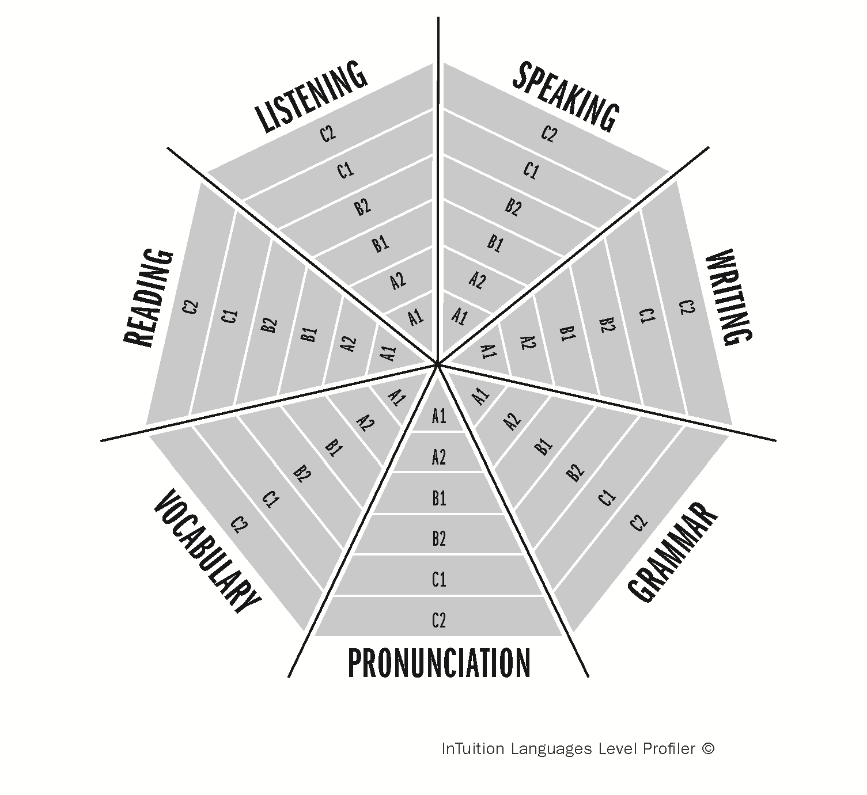
InTuition Languages Level Profiler ©
Student:
Date of Assessment:

